SIMATS ENGINEERING

ASSESSMENT TOOL 1

COURSE NAME: Database Management Systems COURSE CODE: CSA05
G.CHAKRADHAR
192311439

COURSE OUTCOME COVERED

CO5: Implement database operations using query processing, optimization, and transaction management to ensure consistency and reliability. (BL3, BL4)

Activity Tool : Constraint-Based Problem Solving (High) Assessment Tool Weightage: 35%

Dr

QUESTIONS Total Marks: 50
Q.No | Question | Bloom's Level | Marks
1 | Given a complex SQL query with nested joins and sub-queries,  draw the query execution plan and apply heuristic optimization rules step-by-step. | BL4 – Analyze | 5
2 | Apply cost-based optimization to choose between nested-loop join, sort-merge join, and hash join for the given relations with specified tuple counts and page sizes. | BL4 – Analyze | 5
3 | Implement JDBC connectivity in Java to a MySQL database and write code to execute parameterized queries with PreparedStatement. | BL3 – Apply | 5
4 | Given a schedule of four concurrent transactions, determine whether it is conflict-serializable using a precedence graph. | BL4 – Analyze | 5
5 | Demonstrate the application of Basic Two-Phase Locking (2PL) on a given transaction set. Identify and resolve any deadlocks. | BL3 – Apply | 5
6 | Apply the Wait-Die and Wound-Wait timestamp-based deadlock prevention schemes on a given set of transactions requesting locks. | BL4 – Analyze | 5
7 | Given transaction logs with checkpoints, apply the Immediate Update recovery protocol to recover the database after a system failure. | BL3 – Apply | 5

8 | Apply Deferred Update (NO-UNDO/REDO) recovery technique on a given log file with committed and uncommitted transactions. | BL3 – Apply | 5
9 | Design a concurrency control mechanism using strict 2PL for a banking system where T1 transfers funds and T2 reads balance simultaneously. | BL4 – Analyze | 5
10 | Write pseudocode for query optimization using heuristics: push down selection, project early, and order joins by smaller intermediate results. | BL4 – Analyze | 5

Code of Conduct:

I G.Chakradhar(192311439)certify that this submission is my original work and that I have adhered to the guidelines specified for this assessment. I understand that any violation of academic integrity rules will result in disciplinary action.

Signature of the student: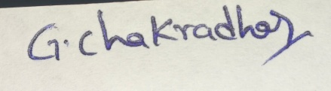

RUBRICS FOR CALCULATION:

Constraint-Based Problem Solving Assessment Rubric
Criteria | Weighta ge | Level 4 (Exemplary) | Level 3 (Proficient) | Level 2 (Developin g) | Level 1 (Beginnin g)
Problem Understanding | 25% | Clearly defines the problem and identifies all relevant constraints accurately | Identifies most constraints with minor gaps | Partial  understandi ng; misses key constraints | Fails to identify constraint s correctly
Constraint Analysis | 25% | Analyzes constraints effectively and prioritizes them logically | Provides reasonable analysis with some prioritization | Limited analysis; weak prioritization | No meaningfu l analysis or  prioritizati on
Solution Development | 25% | Develops optimal and feasible solutions satisfying all constraints | Develops workable solutions with minor limitations | Solutions partially satisfy constraints | Solutions do not meet constraint s
Application of Concepts | 15% | Effectively applies appropriate | Applies concepts with | Limited application; | Unable to apply

 |  | concepts,  methods, or tools | minor errors | requires  guidance | relevant  concepts
Justification | 10% | Provides strong justification for decisions with  logical reasoning | Provides justification with some clarity | Weak or unclear justification | No justificatio n provided

Question 1 | 5 Marks
Question: Given a complex SQL query with nested joins and sub-queries, draw the query execution plan and apply heuristic optimization rules step-by-step.

Answer
A query execution plan is the sequence of operations used by the DBMS to produce the result of an SQL query. Heuristic optimization improves the plan using simple rules that normally reduce the number of rows and columns processed.

Worked Example
SELECT S.name
FROM Student S
JOIN Department D ON S.dept_id = D.dept_id
WHERE D.name = 'CSE' AND S.age > 18;

Step 1 — Initial query tree
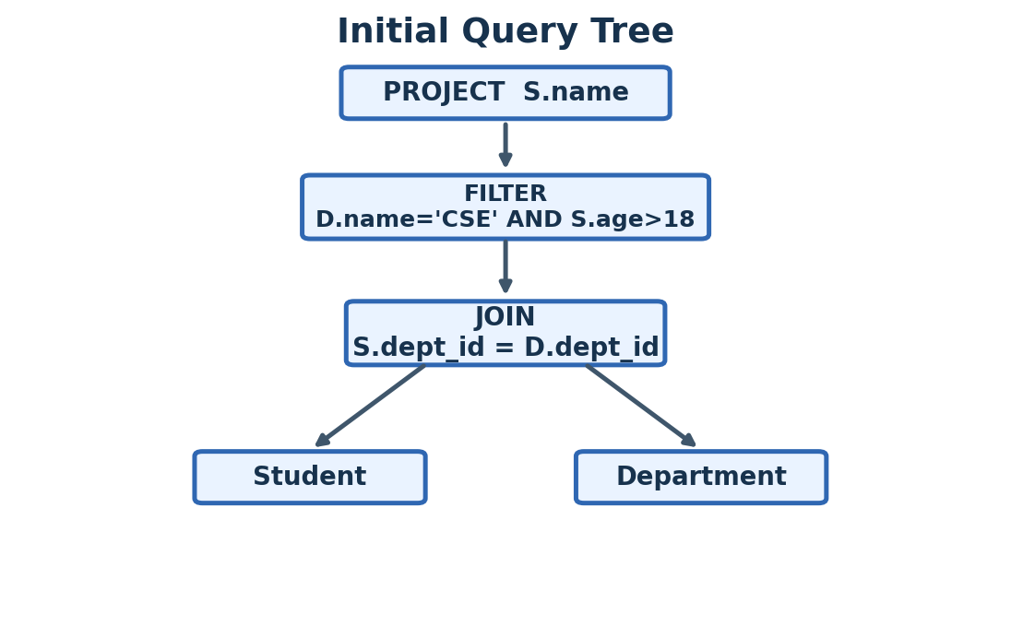
Figure 1. Initial query execution tree

Step 2 — Push selections down
The WHERE conditions should be applied as close as possible to the base tables. This reduces rows before the join.
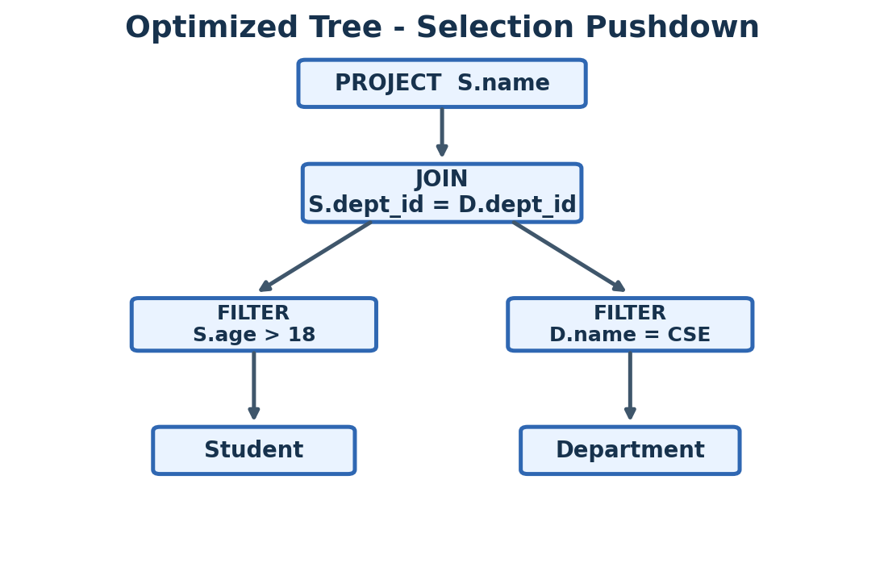
Figure 2. Selection pushdown tree

Step 3 — Project only required columns
Keep only the columns needed for the join and final answer.
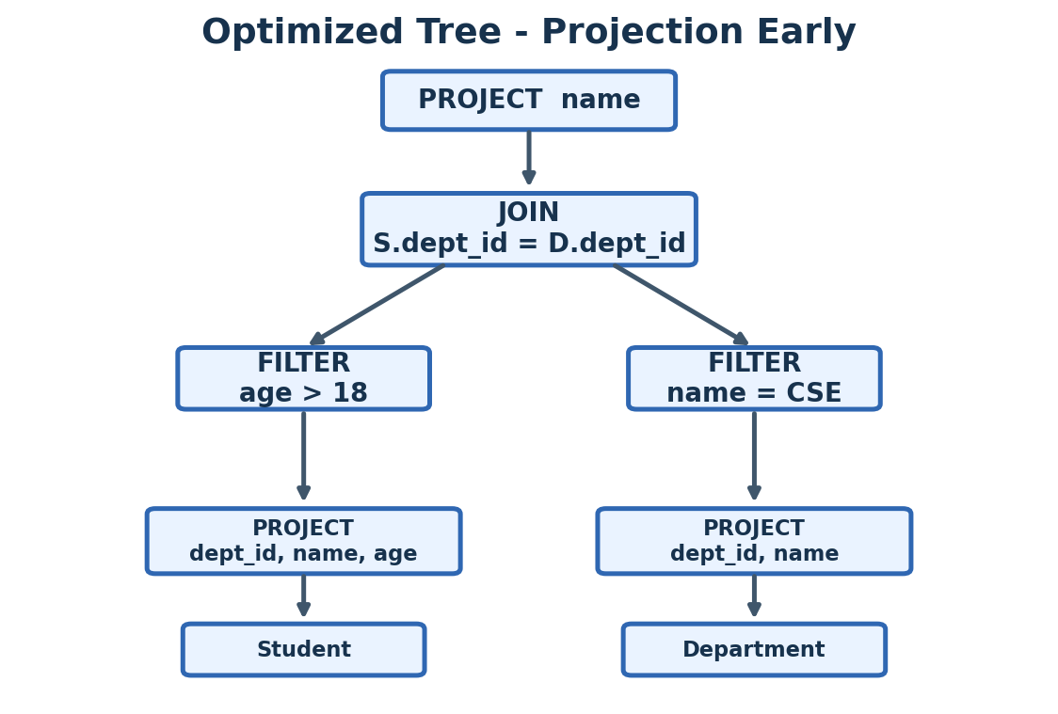
Figure 3. Projection-early optimized tree

Heuristic Rules Used
- Push selection down: apply WHERE conditions early.
- Project early: keep only required columns.
- Perform the most selective/filtering operations before large joins.
- Choose a join order that creates smaller intermediate results.
Final result: The optimized plan filters Student and Department before joining them, so fewer rows are joined. This normally reduces disk I/O, memory use, and execution time.

Question 2 | 5 Marks
Question: Apply cost-based optimization to choose between nested-loop join, sort-merge join, and hash join for the given relations with specified tuple counts and page sizes.

Answer
Cost-based optimization compares the estimated cost of different plans and selects the lowest-cost plan. Because no values were supplied in the question sheet, the following is a complete sample calculation.

Given Example
Relation | Pages (B) | Tuples
R | 100 | 1,000
S | 50 | 500

1) Nested-Loop Join
Using the simple page-oriented estimate with R as the outer relation:
Cost ≈ B(R) + B(R) × B(S)
= 100 + (100 × 50)
= 5,100 page I/Os

2) Sort-Merge Join
An exact cost depends on the memory available for external sorting. For this worked example, use the common simplified estimate:
Cost ≈ 3 × (B(R) + B(S))
= 3 × (100 + 50)
= 450 page I/Os

3) Hash Join
For an equality join, a simplified estimate is roughly two passes over both relations:
Cost ≈ 2 × (B(R) + B(S))
= 2 × 150
= 300 page I/Os
Join Method | Estimated Cost
Nested-loop | 5,100 I/Os
Sort-merge | 450 I/Os
Hash join | 300 I/Os
Final choice: Hash Join, because it has the lowest estimated cost (about 300 page I/Os) for this equality-join example. In an actual exam, use the exact cost formula and values provided by your faculty.

Question 3 | 5 Marks
Question: Implement JDBC connectivity in Java to a MySQL database and write code to execute parameterized queries with PreparedStatement.

Answer
JDBC (Java Database Connectivity) allows a Java program to connect to a database such as MySQL, send SQL commands, and read results.

Basic Flow
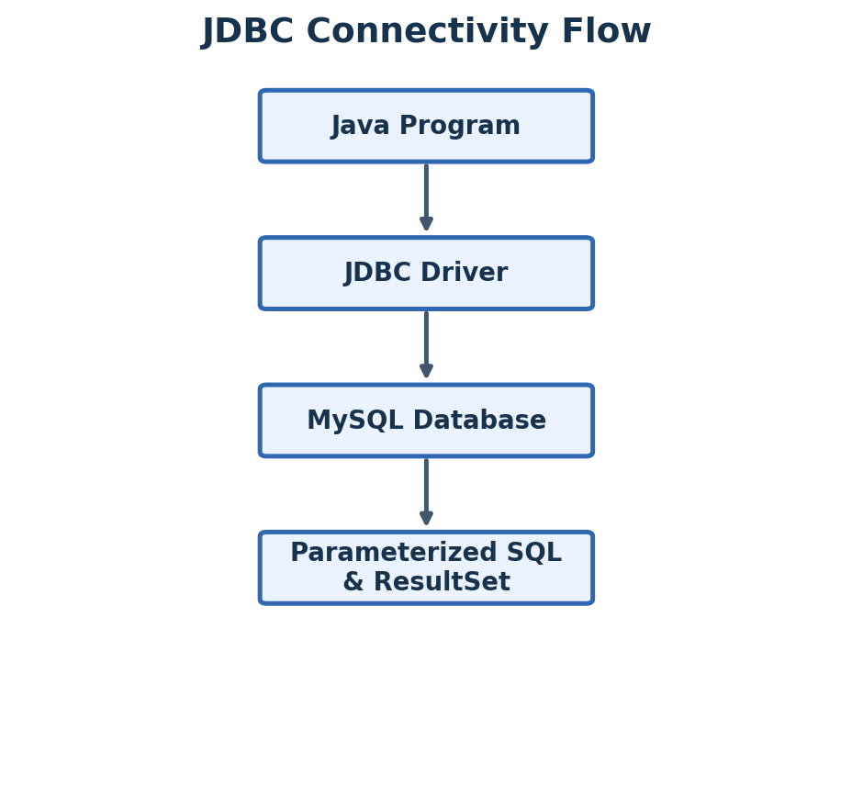
Figure 4. JDBC connectivity flow

Java Program
import java.sql.*;
public class JdbcDemo {
public static void main(String[] args) {
String url = "jdbc:mysql://localhost:3306/college";
String user = "root";
String password = "password";
String sql = "SELECT * FROM Student WHERE dept_id = ?";
try (Connection con = DriverManager.getConnection(url, user, password);
PreparedStatement ps = con.prepareStatement(sql)) {
ps.setInt(1, 10);
ResultSet rs = ps.executeQuery();
while (rs.next()) {
System.out.println(rs.getInt("id") + " " +
rs.getString("name"));
}
} catch (SQLException e) {
e.printStackTrace();
}
}
}

Why PreparedStatement?
- The SQL contains ? as a parameter placeholder.
- setInt(), setString(), etc. supply the values safely.
- It is safer than building SQL by string concatenation and helps prevent SQL injection.
Final result: The program connects Java to MySQL, supplies a parameter through PreparedStatement, executes the SELECT query, and prints the matching rows.

Question 4 | 5 Marks
Question: Given a schedule of four concurrent transactions, determine whether it is conflict-serializable using a precedence graph.

Answer
A schedule is conflict-serializable when its operations can be rearranged into a serial order without changing the result. The standard method is to build a precedence graph.

Worked Example
Schedule:
1. T1: R(A)
2. T2: W(A)
3. T2: R(B)
4. T3: W(B)
5. T1: W(B)
6. T4: R(A)

Step 1 — Find conflicts
- T1 R(A) before T2 W(A) → conflict → T1 → T2.
- T2 R(B) before T3 W(B) → conflict → T2 → T3.
- T2 R(B) before T1 W(B) → conflict → T2 → T1.
- T1 W(B) before T3 W(B) → conflict → T1 → T3.
- T2 W(A) before T4 R(A) → conflict → T2 → T4.

Step 2 — Precedence graph
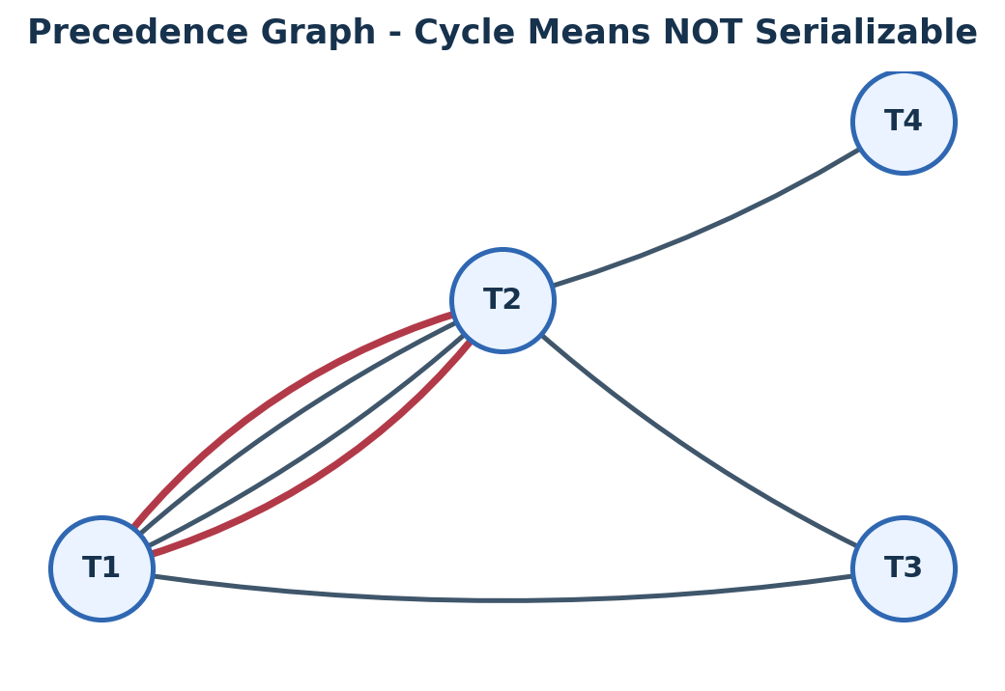
Figure 5. Precedence graph for conflict serializability

Step 3 — Check for cycle
There is a cycle: T1 → T2 → T1. Therefore the graph is not acyclic.
Final result: NOT conflict-serializable, because the precedence graph contains a cycle.

Question 5 | 5 Marks
Question: Demonstrate the application of Basic Two-Phase Locking (2PL) on a given transaction set. Identify and resolve any deadlocks.

Answer
Two-Phase Locking (2PL) has two phases: (1) Growing phase — acquire locks; (2) Shrinking phase — release locks. After a transaction releases its first lock, it cannot acquire a new lock.

Worked Example
T1: LOCK-X(A); WRITE(A); LOCK-X(B); WRITE(B); UNLOCK(A); UNLOCK(B)
T2: LOCK-X(B); WRITE(B); LOCK-X(A); WRITE(A); UNLOCK(B); UNLOCK(A)
Suppose T1 obtains X(A) and T2 obtains X(B). Then both ask for the other lock:
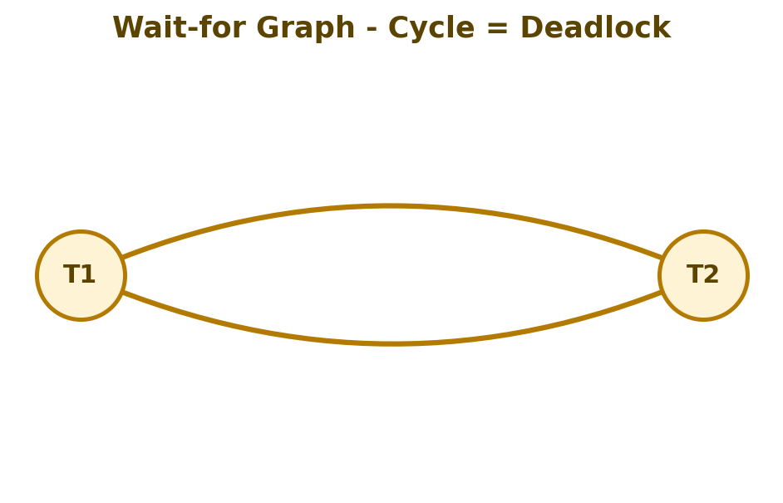
Figure 6. Wait-for graph showing deadlock

Resolution
A simple resolution is to abort one transaction, release its locks, and restart it later. Suppose T2 is aborted:
T1: X(A), X(B), WRITE(A), WRITE(B), COMMIT, UNLOCK(A), UNLOCK(B)
T2: ABORT → release B → restart T2 after T1 completes
Final result: Basic 2PL is satisfied when each transaction acquires locks first and releases them later. A deadlock occurs if transactions wait for each other in a cycle. Break the deadlock by aborting/rolling back one transaction and releasing its locks.

Question 6 | 5 Marks
Question: Apply the Wait-Die and Wound-Wait timestamp-based deadlock prevention schemes on a given set of transactions requesting locks.

Answer
Assume smaller timestamp = older transaction.
T1 timestamp = 5 → older
T2 timestamp = 10 → younger

Case A — T2 requests a lock held by T1
Scheme | Rule | Action
Wait-Die | Younger requests from older | T2 aborts (dies)
Wound-Wait | Younger requests from older | T2 waits

Case B — T1 requests a lock held by T2
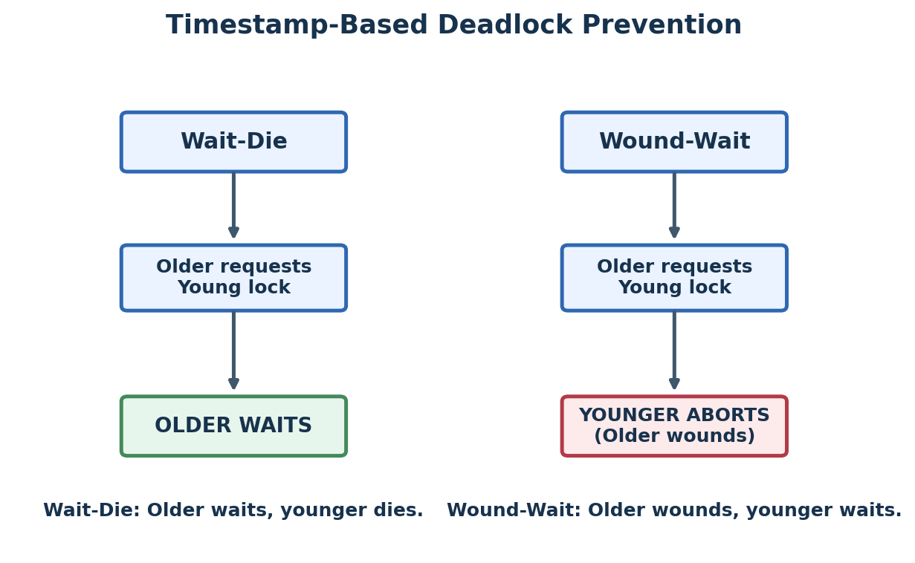
Figure 7. Wait-Die and Wound-Wait comparison
Scheme | Rule | Action
Wait-Die | Older requests from younger | T1 waits
Wound-Wait | Older requests from younger | T1 wounds/aborts T2

Easy Memory Trick
Wait-Die: Older waits, Younger dies. | Wound-Wait: Older wounds, Younger waits.

Question 7 | 5 Marks
Question: Given transaction logs with checkpoints, apply the Immediate Update recovery protocol to recover the database after a system failure.

Answer
Immediate Update means a changed value may be written to the database before the transaction commits. Therefore recovery may need both UNDO and REDO.

Worked Example Log
<T1 START>
<T1, A, 100, 150>
<T1 COMMIT>
<CHECKPOINT {T1}>
<T2 START>
<T2, B, 200, 250>
<T3 START>
<T3, C, 300, 350>
<T3 COMMIT>
SYSTEM CRASH

Step 1 — Identify transactions
- T1 committed before the checkpoint.
- T2 started but did not commit.
- T3 committed before the crash.

Step 2 — Recovery action
- T1: no action needed because its committed work is already safe before the checkpoint.
- T3: REDO its logged update if needed because it committed after the checkpoint.
- T2: UNDO its update because it was active and uncommitted at the crash.
Recovery summary:
T1 → keep committed result A = 150
T2 → UNDO B = 250 back to 200
T3 → REDO C = 350
Final database state in this example: A = 150, B = 200, C = 350. The important rule is: committed transactions after the checkpoint may be REDOed; incomplete transactions are UNDOed.

Question 8 | 5 Marks
Question: Apply Deferred Update (NO-UNDO/REDO) recovery technique on a given log file with committed and uncommitted transactions.

Answer
In Deferred Update, changes are not written to the database until the transaction commits. Therefore an uncommitted transaction does not need UNDO. The recovery method is called NO-UNDO/REDO.

Worked Example Log
<T1 START>
<T1, A, 100, 150>
<T1 COMMIT>
<T2 START>
<T2, B, 200, 250>
<T3 START>
<T3, C, 300, 350>
<T3 COMMIT>
SYSTEM CRASH

Recovery
- T1 committed → REDO T1.
- T2 did not commit → ignore T2. No UNDO is required.
- T3 committed → REDO T3.
REDO T1 → A = 150
IGNORE T2 → B remains 200
REDO T3 → C = 350
Final result: A = 150, B = 200, C = 350. Deferred Update uses NO-UNDO/REDO because uncommitted transactions have not yet changed the database.

Question 9 | 5 Marks
Question: Design a concurrency control mechanism using strict 2PL for a banking system where T1 transfers funds and T2 reads balance simultaneously.

Answer
Strict 2PL keeps write locks until commit. This prevents another transaction from reading or changing data that is part of an uncommitted transfer.

Scenario
Account A = ₹1000
Account B = ₹500
T1 transfers ₹100 from A to B.
T2 wants to read the balance of A and B.

T1 — Transfer
BEGIN T1
LOCK-X(A)
LOCK-X(B)
A = A - 100
B = B + 100
COMMIT
UNLOCK(A)
UNLOCK(B)

T2 — Read balances
BEGIN T2
LOCK-S(A)
LOCK-S(B)
READ A
READ B
COMMIT
UNLOCK(A)
UNLOCK(B)
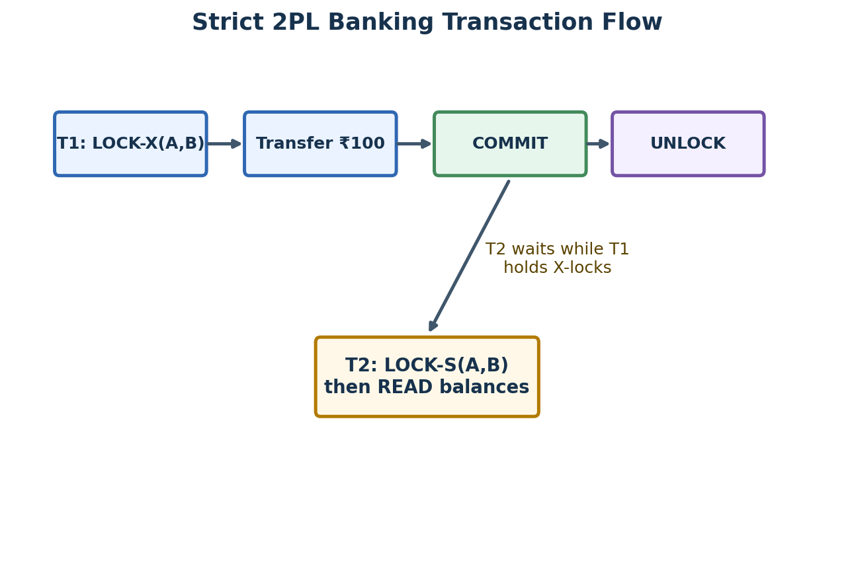
Figure 8. Strict 2PL banking transaction flow
If T2 requests its shared locks while T1 still holds exclusive locks, T2 waits. After T1 commits and releases the locks, T2 continues and sees a consistent state.

Why this is safe
- T2 cannot read a half-completed transfer.
- The transfer is atomic from the other transaction’s point of view.
- Strict 2PL avoids dirty reads and inconsistent intermediate balances.
Final design: T1 locks both accounts using exclusive locks, performs the transfer, commits, and only then releases the locks. T2 waits when necessary, then reads the committed balances with shared locks.

Question 10 | 5 Marks
Question: Write pseudocode for query optimization using heuristics: push down selection, project early, and order joins by smaller intermediate results.

Answer
The optimizer receives an SQL query, rewrites it using heuristic rules, and produces an execution plan with smaller intermediate results.

Pseudocode
ALGORITHM HeuristicQueryOptimization(Query):
1. Parse Query into relations, selections, projections and joins.
2. Push down selections:
For every WHERE condition, move the condition
as close as possible to its base relation.
3. Project early:
For each relation, keep only columns needed for
selections, joins and the final output.
4. Estimate the size of intermediate relations.
5. Order joins:
Choose the join that produces the smallest
intermediate result first.
6. Build the optimized query tree / execution plan.
7. Return the optimized plan.
END ALGORITHM

Optimization Flow Diagram
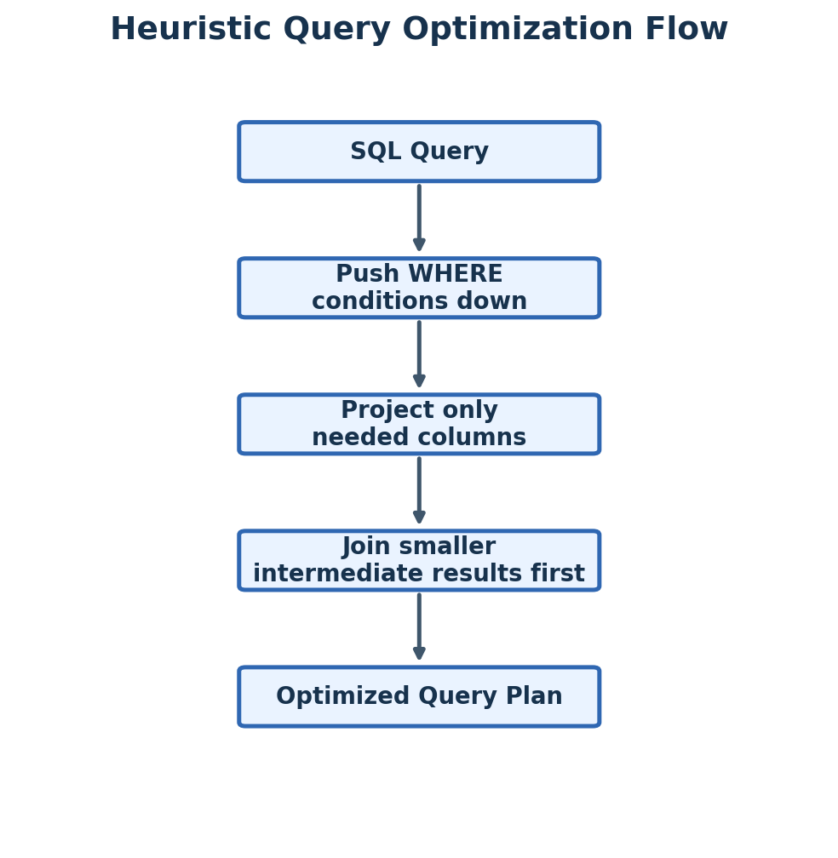
Figure 9. Heuristic query optimization flow
Final result: The heuristic optimizer reduces the amount of data processed before expensive operations such as joins. This usually improves query response time and reduces I/O.

Final Revision Sheet
Topic | One-line memory rule
Heuristic optimization | Filter early, project early, join smaller results first.
Cost-based optimization | Estimate costs and choose the cheapest plan.
PreparedStatement | Use ? placeholders and set values safely.
Conflict serializability | Precedence graph with no cycle = serializable.
2PL | Growing phase first, shrinking phase second.
Wait-Die | Older waits, younger dies.
Wound-Wait | Older wounds, younger waits.
Immediate update | Recovery can need UNDO and REDO.
Deferred update | NO-UNDO/REDO: REDO committed, ignore uncommitted.
Strict 2PL | Keep write locks until commit to protect consistency.

Exam tip: For every 5-mark problem, write the Given data, show 3–5 clear steps, draw the required graph/tree/table, and finish with a one-line Final Result. This makes your answer easy to evaluate.

